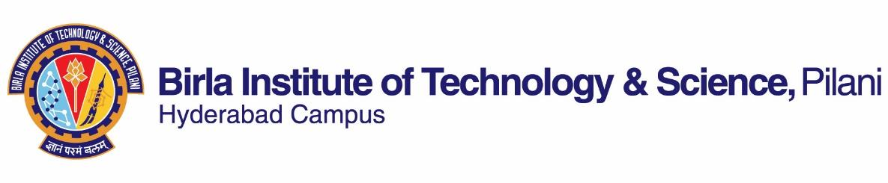

**SECOND SEMESTER 2019-2020**

# Course Handout Part II

Date: 06-01-2020

In addition to part-I (General Handout for all courses appended to the time table) this portion gives further specific details regarding the course.

*Course Number* **: BITS F214**

*Course Title* **: Science, Technology and Modernity**

*Instructor-in-charge* **: Biswanath Dash**

**COURSE DESCRIPTION**

The course is aimed at exploring the interrelationship between modern society and science/ technology. Specifically, it seeks to interrogate the relationship in terms of analyzing emergence of modern science in the western world and its implication and contribution to the idea of a modern society. It covers to an extent, the impact of such development in India and examines the contemporary debates over the role of science/technology within modernization and globalization.

**Text Book:**

1. McCllelan III, J.E. and Dorn, H. 2006. *Science and Technology in World History*, Second Edition, Maryland: John Hopkin University Press

**Reference Book:**

1. Reading material to be uploaded on CMS
2. Bernal, J.D. 1971 *Science in History* Vol. 2. Massachusetts: MIT Press

**Course Plan:**

|  |  |  |  |
| --- | --- | --- | --- |
| **Lecture**  **No.** | **Learning Objectives** | **Topics to be covered** | **Chapter in the Text Book** |
| 1-3 | Gain an overall perspective of the course | Course Structure  Science and Technology and Modern society | TB Part I  Reading Material |
| 4-15 | Learn about origin and evolution of Natural Philosophy/Science in different cultures | Greek Natural Philosophy, Arabic Middle Ages  Chinese and  South American Civilization | TB Part I and II  Reading Material |
| 16-25 | Examine emergence of modern science and its role in industrial revolution in the western world | Renaissance,  Scientific and  Industrial Revolution | TB Part III and IV |
| 26-32 | Analyze evolution of Science/ Technology in India and its role in shaping Indian society | Vedic period/Gupta era/Moghul period  Colonial India | Reading material |
| 33-42 | Appreciate ‘modernity’ as an idea and its relationship to science and technology | Enlightenment promise of progress,  Critiques of Modernity,  Technology in Globalization | Reading material |

**Evaluation Scheme:**

|  |  |  |  |  |
| --- | --- | --- | --- | --- |
| **Component** | **Duration** | **Weightage** | **Date, Time and Venue** | **Nature of Component** |
| Mid Semester Exam | 90 minutes | 30% | 3/3 3.30 - 5.00 PM | Closed Book |
| Assignment 1 & 2 |  | 30% |  | Open Book |
| Comprehensive Examination | 180 minutes | 40% | 05/05 AN | Closed Book |

**Chamber Consultation Hour:** Thursday 11-12. Room No. K 118, Department of Humanities and Social Sciences, BITS Pilani, Hyderabad Campus

**Notices:** Notices, if any, will be displayed on Department Notice Board and CMS.

**Make-up Policy:** The make-up for an evaluation component will be given only in genuine cases. In health related issues student has to bring a letter from warden as per the latest SWD guidelines.

**Academic Honesty and Integrity Policy:** Academic honesty and integrity are to be maintained by all the students throughout the semester and no type of academic dishonesty is acceptable.

**Biswanath Dash**

**INSTRUCTOR-IN-CHARGE**